**POINTERS (PART 2 POINTERS WITH**

**ARRAYS AND FUNCTIONS**

**LAB # 9**



**Spring 2022**

**CSE102L Computer Programming Lab**

Submitted by: **Ali Asghar**

Registration No. : **21PWCSE2059**

Class Section: **C**

“On my honor, as student of University of Engineering and Technology, I have neither given nor received unauthorized assistance on this academic work.”

Student Signature: ______________

Submitted to:

**Engr. Abdullah Hamid**

July 4, 2022

Department of Computer Systems Engineering

University of Engineering and Technology, Peshawar

**Lab Objective(s)**

* To understand pointer role in arrays and functions

**TASK # 1:**

**Title:**

Write a C++ program…………..and displaying the values must be done using a single pointer

**CODE SCREENSHOTS:**

Here are the screenshots of the code.

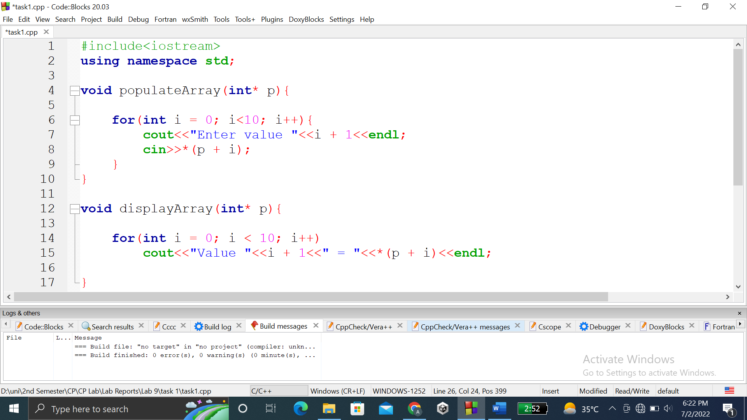

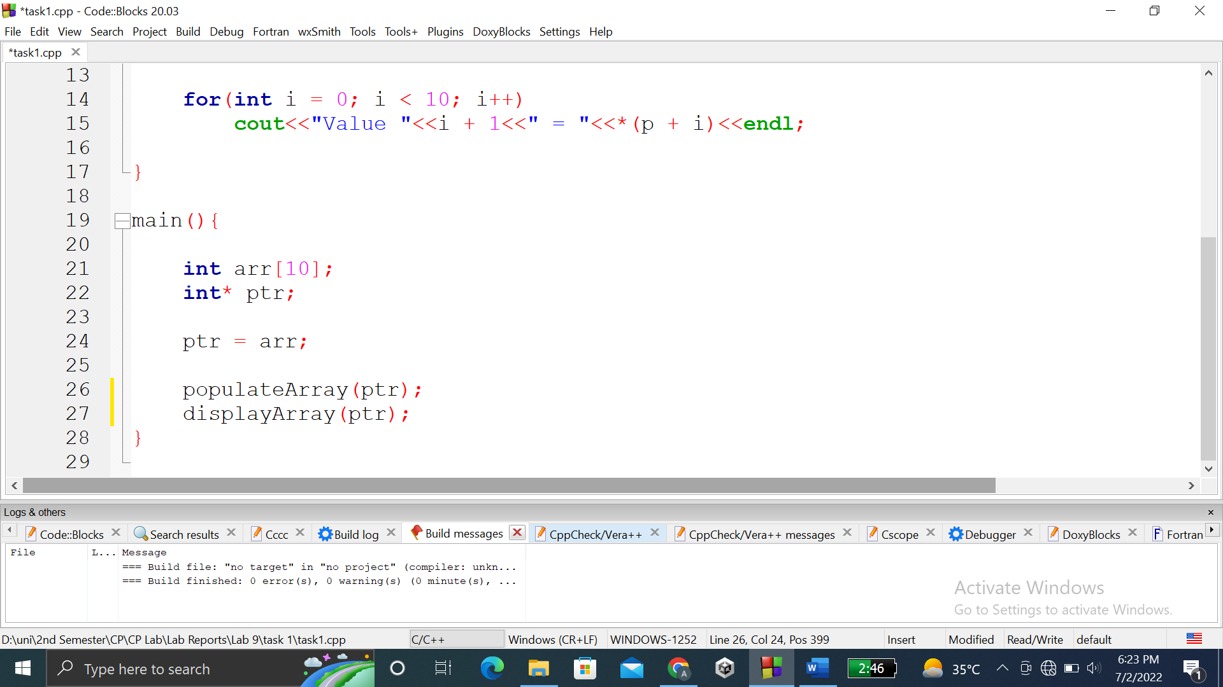

### **OUTPUT (COMPILATION, DEBUGGING & TESTING):**

Here is the screenshot of the output of above code.

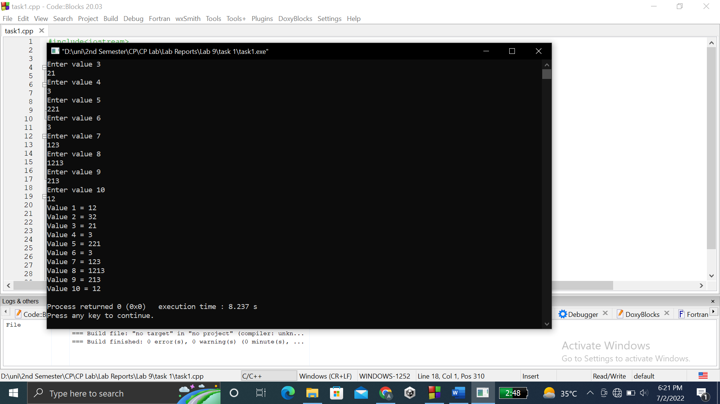

**TASK # 2:**

**Title:**

Write a program to input twelve numbers from use………input values into the array and use pointer for outputting the values.

**CODE SCREENSHOTS:**

Here are the screenshots of the code.

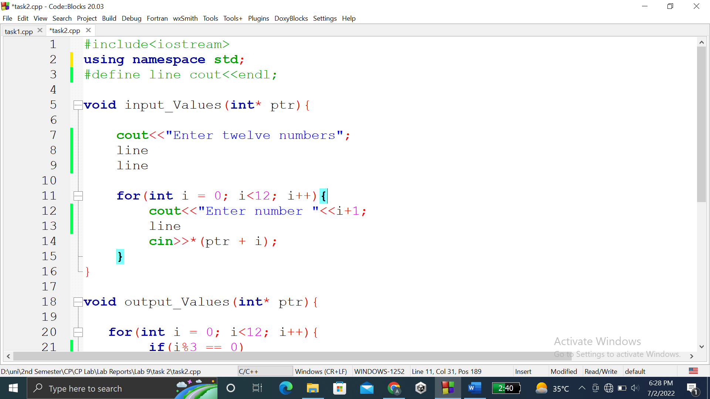

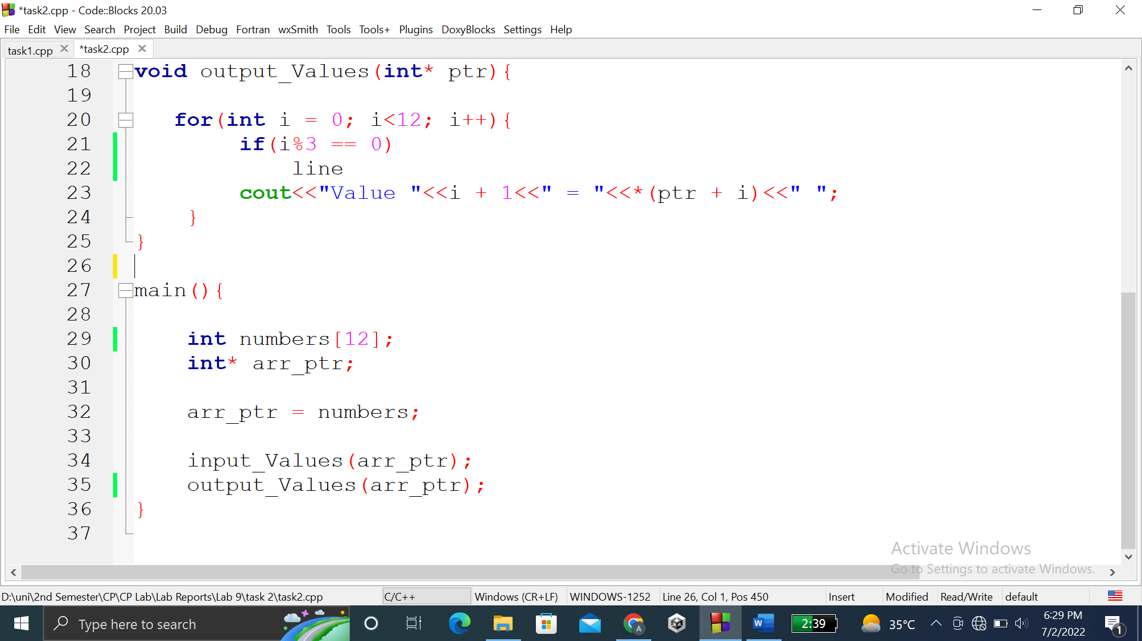

### **OUTPUT (COMPILATION, DEBUGGING & TESTING):**

Here are the screenshots of the output of above code.

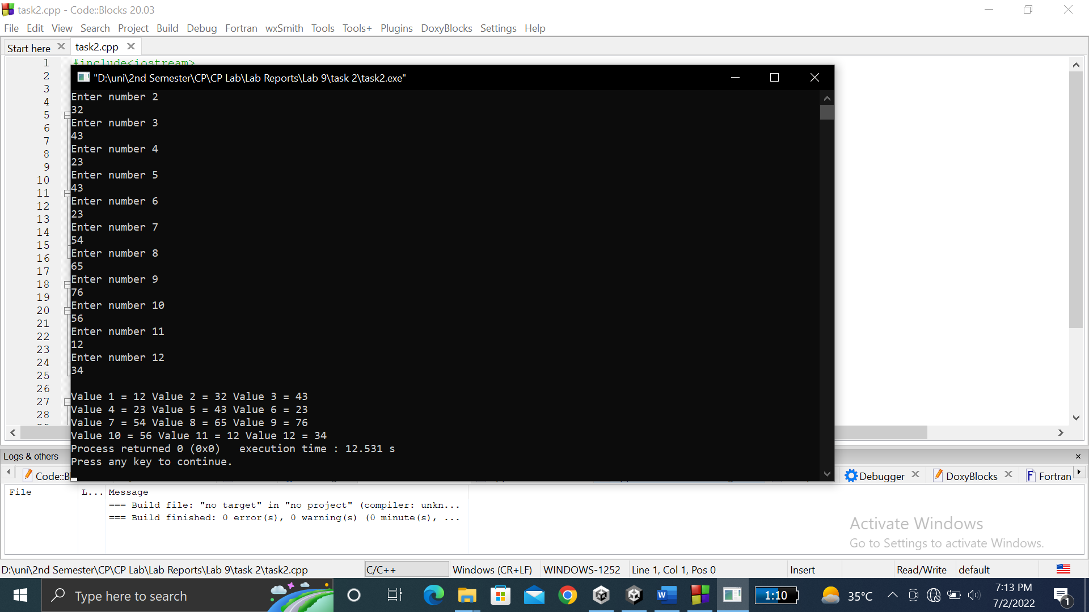

**TASK # 3:**

**Title:**

Write a program where you create a string array of size 2……….Display them both then using the pointer.

**CODE SCREENSHOTS:**

Here are the screenshots of the code.

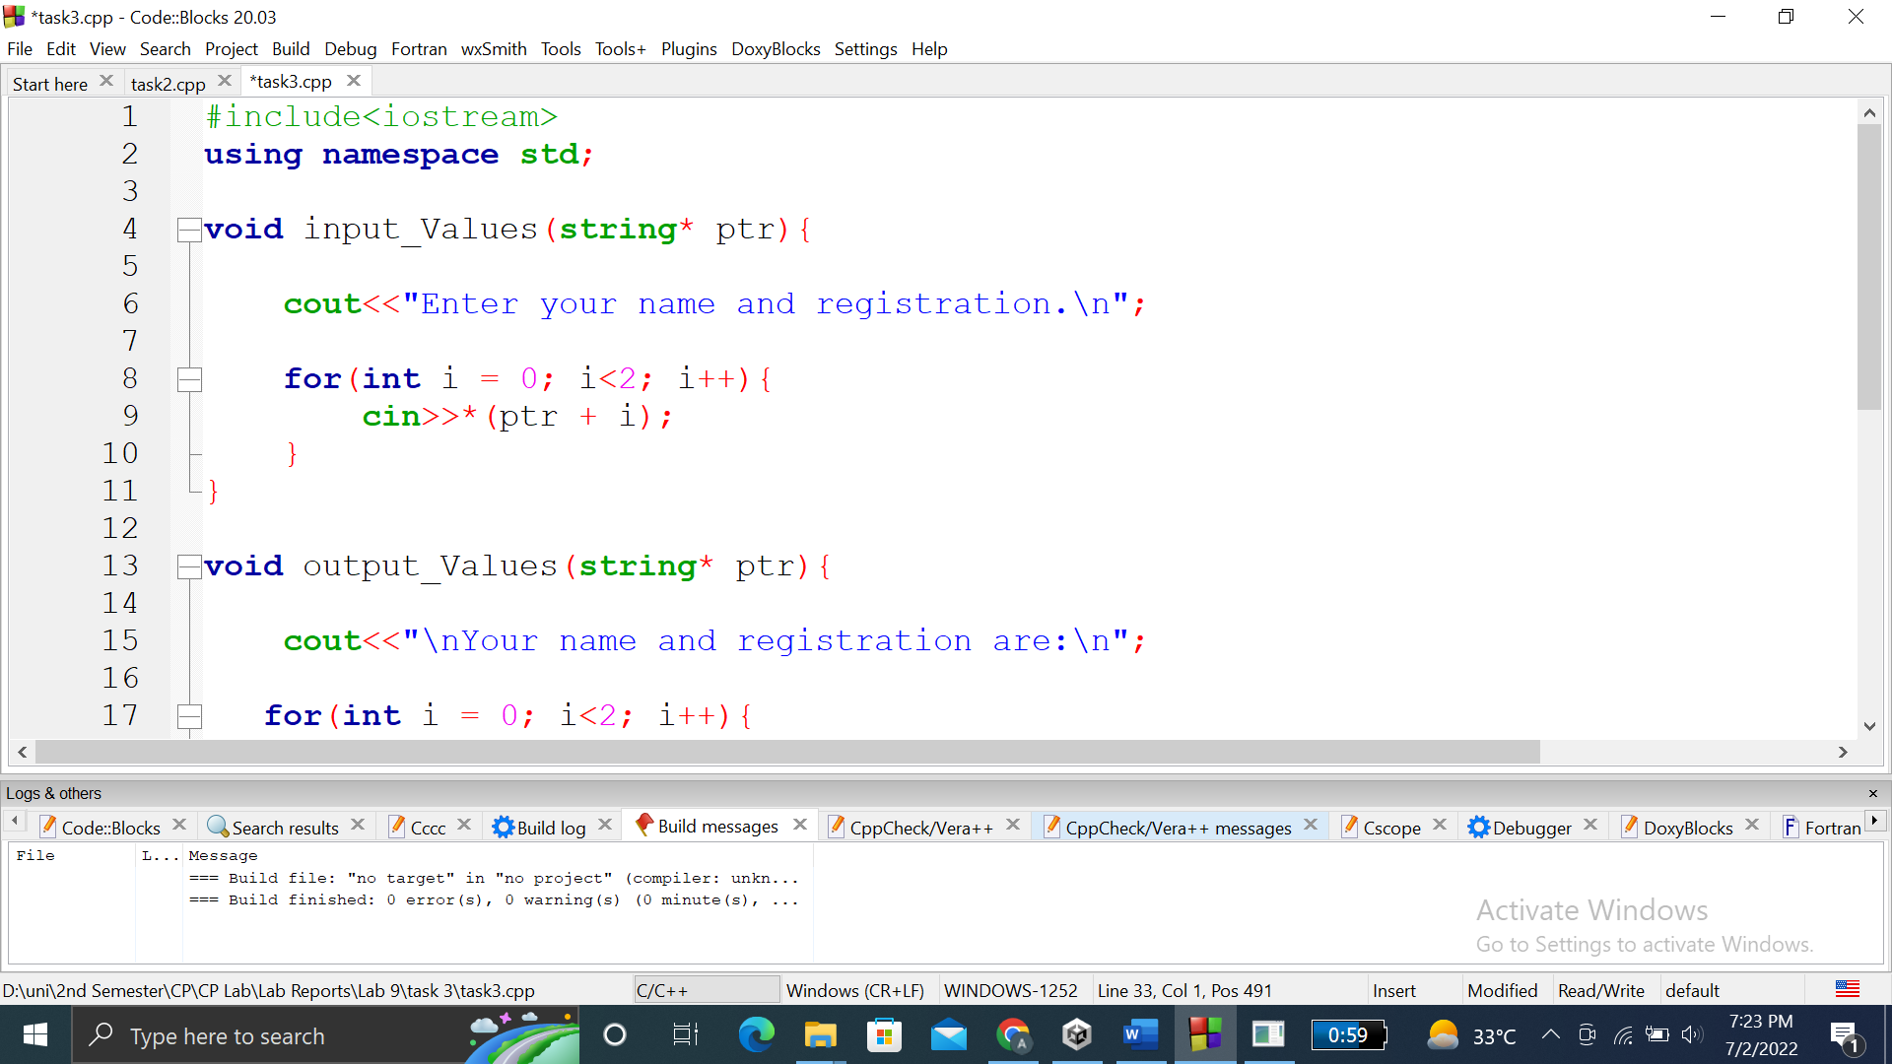

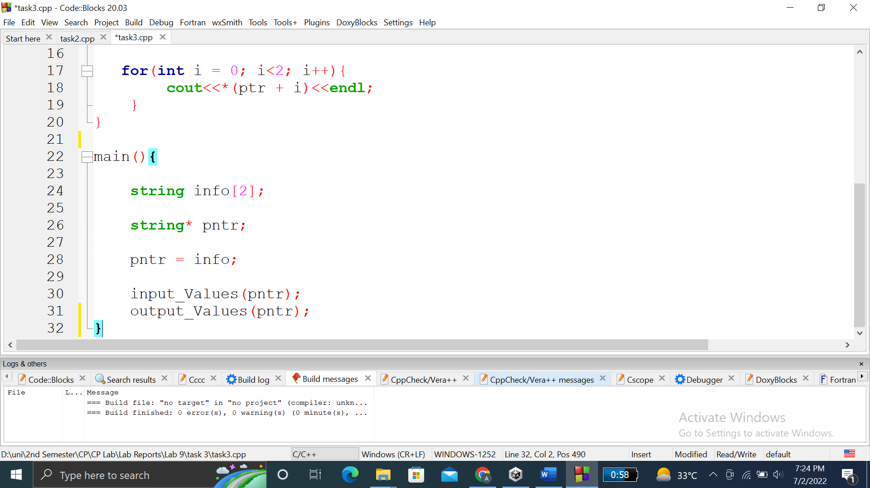

### **OUTPUT (COMPILATION, DEBUGGING & TESTING):**

Here is the screenshot of the output of above code.

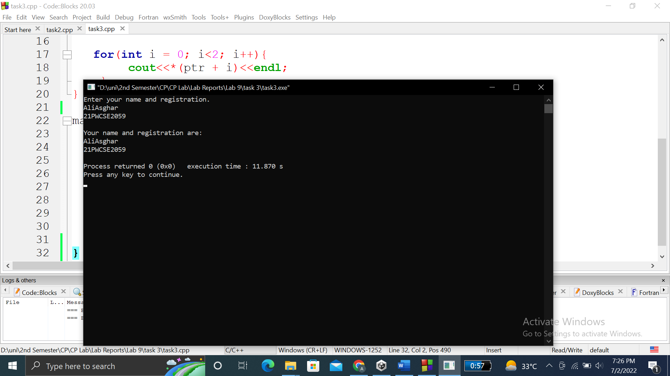

**TASK # 4:**

**Title:**

Write a program which calculates the……………..(which is the size of array) i.e average(int *arr , int size).

**CODE SCREENSHOTS:**

Here is the screenshot of the code.

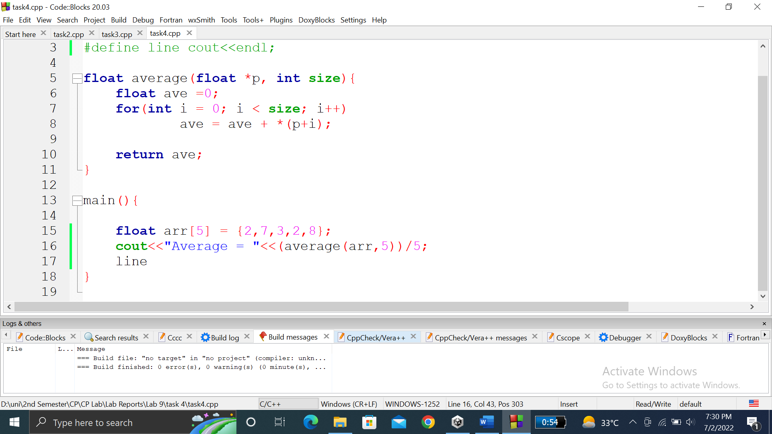

### **OUTPUT (COMPILATION, DEBUGGING & TESTING):**

Here is the screenshot of the output of above code.

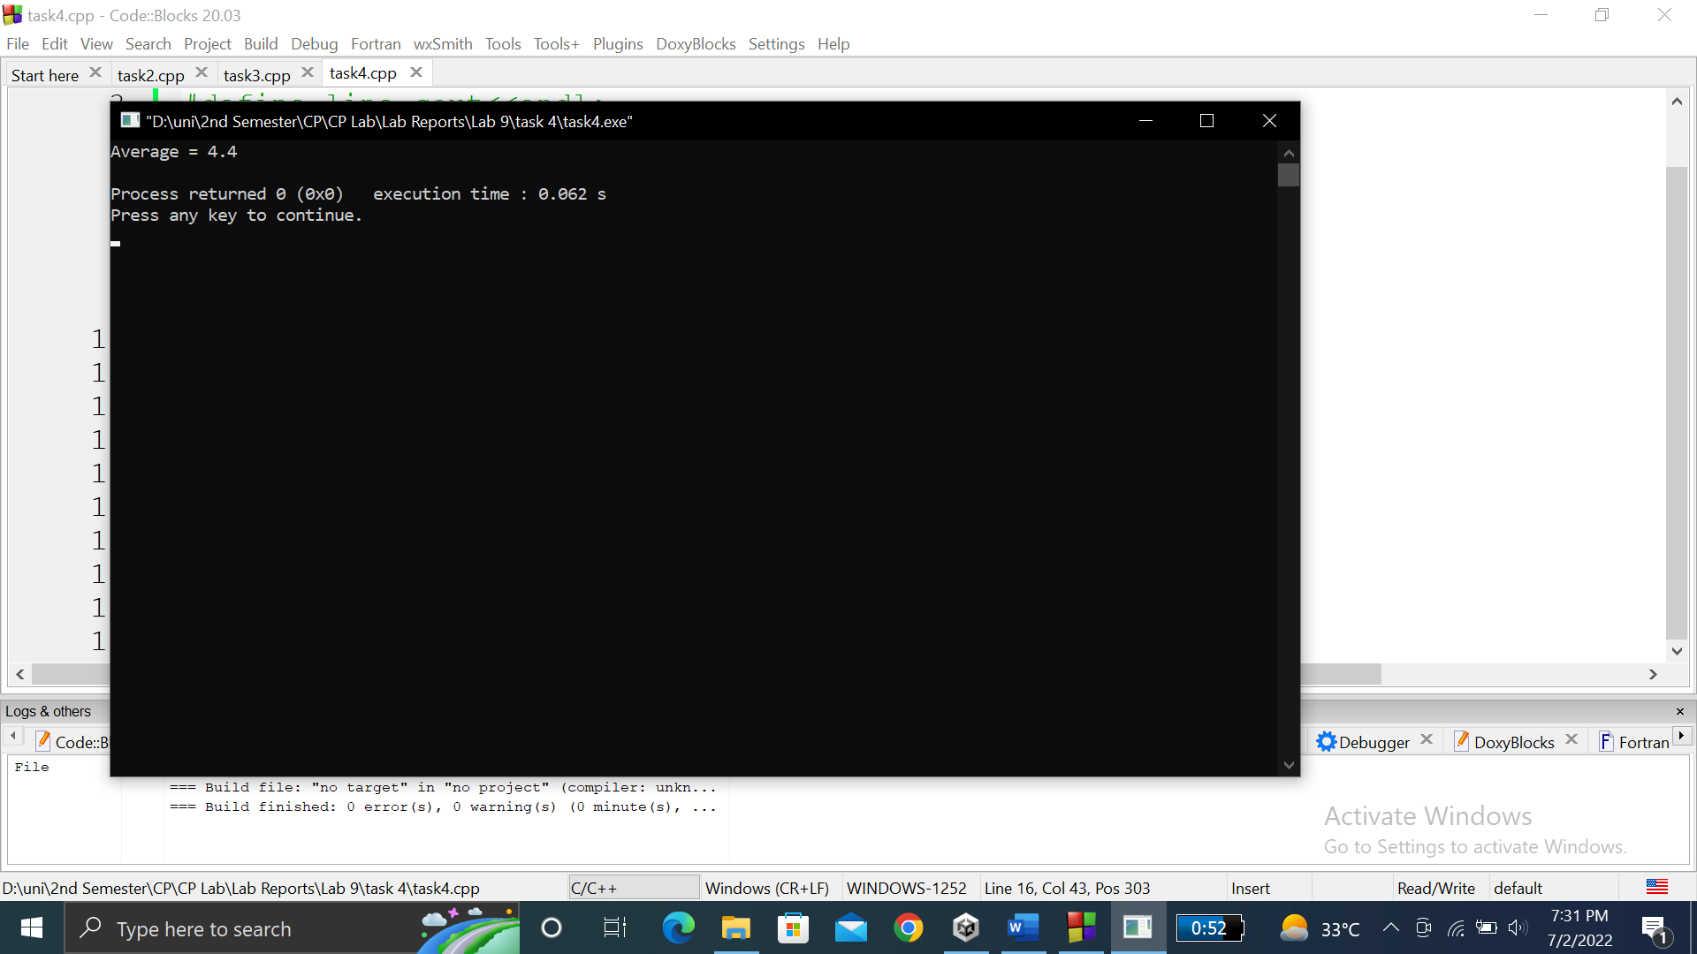

**TASK # 5:**

**Title:**

Write a C++ program where you declare an array of 5………….the first index of array in main().

**CODE SCREENSHOTS:**

Here are the screenshots of the code.

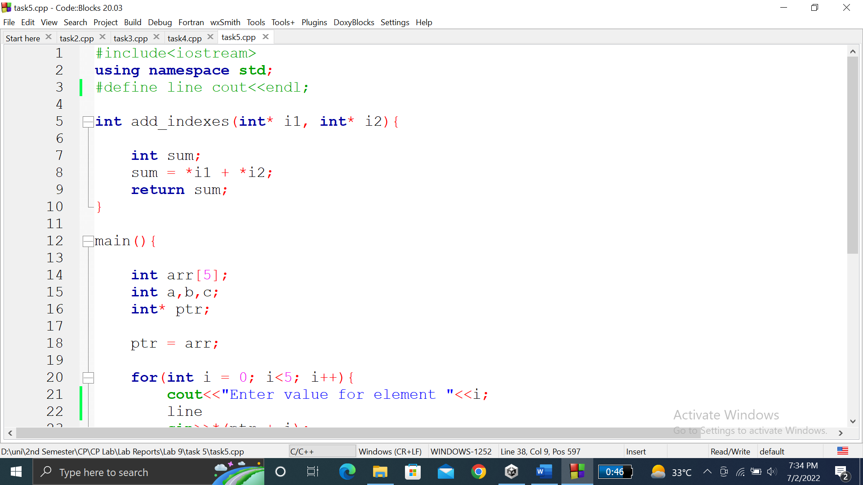

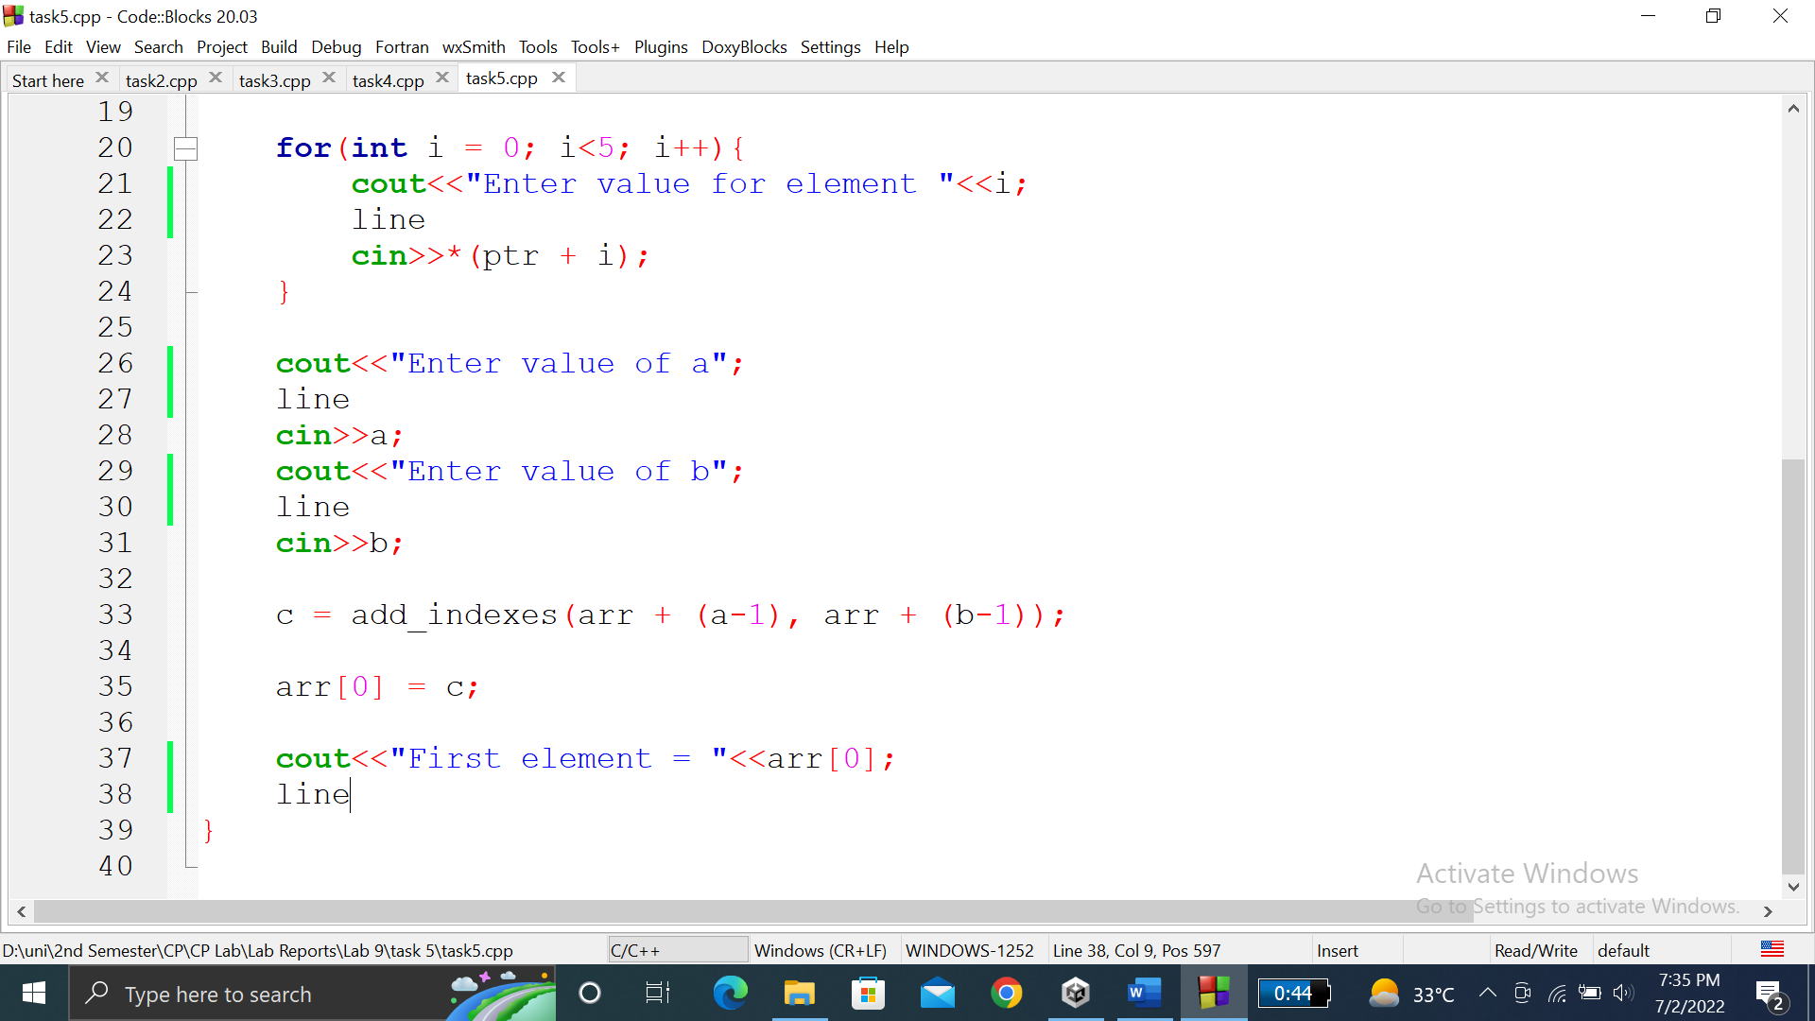

### **OUTPUT (COMPILATION, DEBUGGING & TESTING):**

Here is the screenshot of the output of above code.

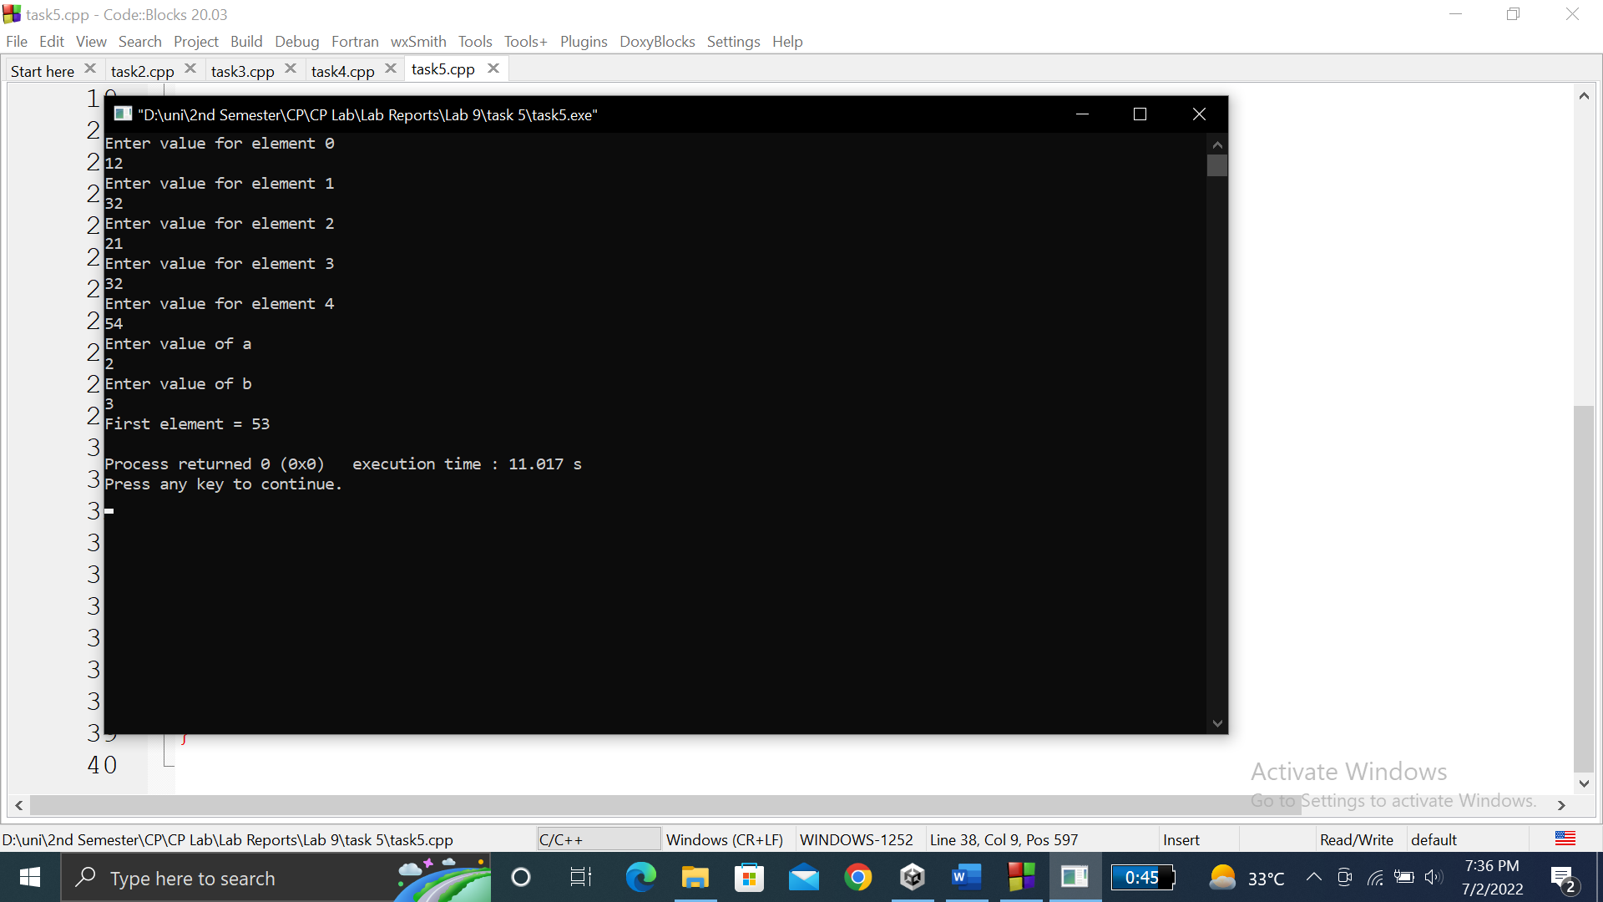

**TASK # 6:**

**Title:**

Write a C++ program where you create 4………….in main() x value will become 9.

**CODE SCREENSHOTS:**

Here are the screenshots of the code.

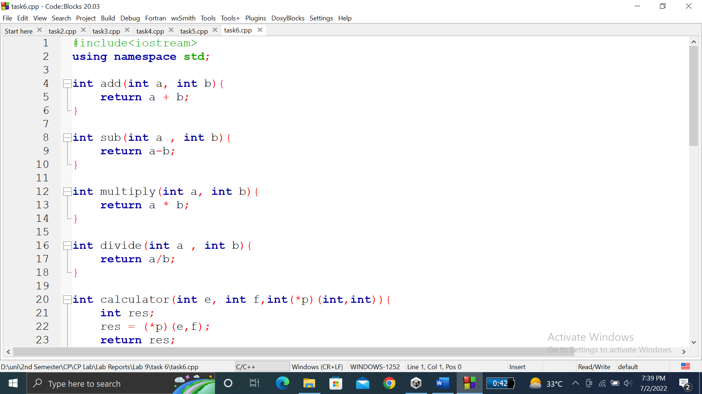

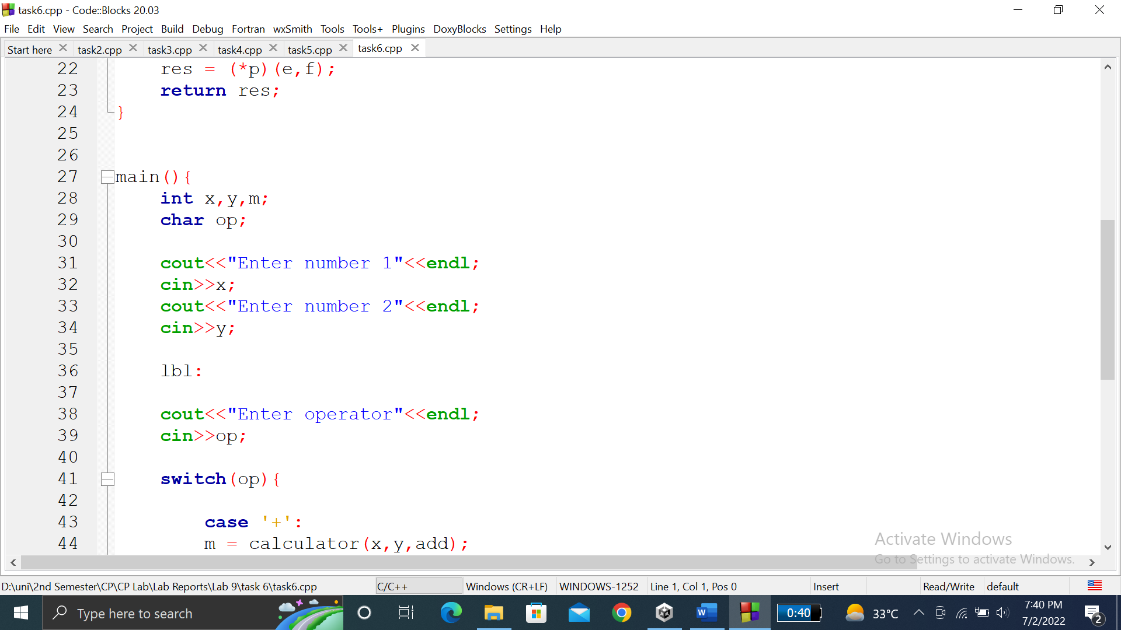

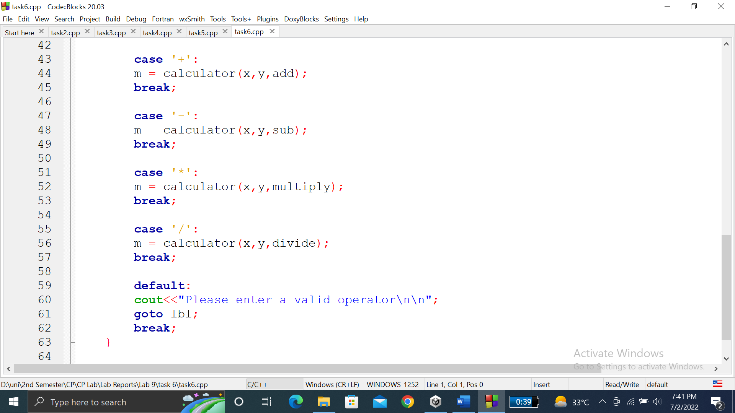

### **OUTPUT (COMPILATION, DEBUGGING & TESTING):**

Here are the screenshots of the output of above code.

